Title: Climate Economics 101

Subtitle: Must-knows
Climate economics is full of acronyms, scenarios, and temperature targets. This article sets out the minimum toolkit needed to understand global climate policy.
While there is nothing new in this article for experienced climate economists, we hope it serves as a useful guide for those hoping to read into the topic.

Global Climate Agreements: The Policy Backbone
Although nations and regions operate their own domestic climate policies, the backbone of international climate policy is a series of conventions, protocols, and agreements.
First, came the United Nations Framework Convention on Climate Change (UNFCCC). This is the foundational international treaty governing global cooperation on climate change. It was adopted at the Rio Earth Summit in 1992 and came into force in 1994, with participation from virtually every country.
The UNFCCC’s ultimate goal was to stabilise greenhouse gas concentrations in the atmosphere “at a level that would prevent dangerous anthropogenic (human induced) interference with the climate system.” Note the focus on stabilisation, not elimination, and concentrations, not annual emissions.
It also established several key principles - this is where economics begins to enter the picture:
- Cost effectiveness. Emissions mitigation efforts should be focused on the most cost effective policies and measures, so that global benefits are achieved at the lowest possible cost.
- Common but Differentiated Responsibilities (CBDR). All countries share responsibility for climate change, but not equally. This reflects historical emissions, differences in income and capacity, and development needs. It embeds equity constraints into global policy.
- Development comes first (within limits). Economic development and poverty reduction matter and climate action should not unduly constrain this. This is why early agreements placed obligations mainly on developed countries and, as we shall see below, the Paris Agreement relies on nationally determined pledges rather than uniform targets.
- Precaution under uncertainty. Scientific uncertainty is not a reason to delay action, but policy should remain flexible as evidence evolves.
Most importantly, the UNFCCC is a framework that paved the way for subsequent agreements, but it is not an action plan in itself. It set out goals and principles, as well as creating institutions, reporting systems, and a forum for negotiation. It does not set binding emissions targets, specify policy, or enforce compliance.
Then came the Kyoto Protocol, which was adopted in 1997 at COP3 and came into force in 2005. It was the first international agreement to impose legally binding greenhouse gas emissions targets, though it had limits to its coverage.
It divided countries into two groups, under the CBDR principle in the UNFCCC:
- Mostly developed economies were committed to cutting emissions by around 5% below 1990 levels for the period 2008-2012.
- Mostly developing countries, which had no binding commitments.
Again, enter economics. Rather than mandating how emissions should be reduced, Kyoto allowed countries to meet targets through market-based mechanisms. This introduced:
- Emissions trading, intended to provide cost-effective abatement through carbon markets. See our article A Short History of the Voluntary Carbon Market for more information on the evolution of this concept.
- The Clean Development Mechanism (CDM), allowing developed countries to finance emissions-reducing projects in developing countries and receive offset credits in return.
- Joint Implementation (JI), which is similar to the CDM but between two developed countries.
The key insight from all this is that the Kyoto Protocol applied the UNFCCC principle of cost effectiveness, so that abatement occurs where it is cheapest, regardless of location.
Despite its innovations, the Kyoto Protocol had major limitations. Major emitters such as China and India had no binding targets, while the United States never ratified the Protocol. This left well over half of global emissions uncovered. Moreover, penalties for non-compliance were modest and there was no credible enforcement mechanism.
The obvious need to address these limitations led to the Paris Agreement, which was adopted in 2015 at COP21 and entered into force in 2016. It applies to all countries, not only developed countries, and commits to the core temperature goals we are used to reading today: a dual temperature objective relative to pre-industrial levels: to hold increases well below 2°C, pursue efforts to limit warming to 1.5°C.
Importantly, these goals can be translated into so-called carbon budgets (more on this below) and imply the need to reach net zero emissions before those carbon budgets are spent.
Central to this are Nationally Determined Contributions (NDCs), where each country sets its own emissions target, chooses how to meet it, and updates it every five years. There are no binding emissions caps and no enforcement penalties: in practice, the Paris Agreement prioritised near-universal participation over binding emissions targets and cost-effective abatement.

What the IPCC is — and What It Is Not
We have provided a guided tour of international climate policy, we now turn to international climate science and the Intergovernmental Panel on Climate Change (IPCC). The IPCC was established by the World Meteorological Organization (WMO) and United Nations Environment Programme (UNEP), so it predates the UNFCCC.
In the late 1980s and early 1990s it established that climate change was real, linked emissions to warming, and motivated governments to negotiate the UNFCCC. To this day, it informs UNFCCC negotiations including the Kyoto Protocol and Paris Agreement.
To do this, it synthesises thousands of peer-reviewed studies, assesses the strength and uncertainty of evidence, and produces consensus reports agreed by governments and scientists. Its most recent release was in 2023.
The IPCC therefore does not determine policy but it does determine the scientific constraints that policy must achieve. Most importantly, it finds that climate risks increase substantially between 1.5°C and 2°C of warming, with higher impacts on extreme heat, water stress, food security, sea level rise, and ecosystems. This explains the Paris Agreement’s use of these temperature increases.
The IPCC also provides estimates of the following three concepts which underpin quantitative climate policy analysis: climate sensitivities, carbon budgets, and standardised scenario frameworks. We now consider these in turn.

Climate Sensitivities: From Emissions to Warming
A central question in climate economics is how emissions translate into temperature change. The IPCC summarises this relationship using a concept known as the Transient Climate Response to Cumulative Emissions (TCRE). The TCRE links:
Total cumulative CO₂ emissions → expected global temperature rise
The key insight is strikingly simple: warming is approximately linear in cumulative CO₂ emissions. This means that each additional tonne of CO₂ contributes roughly the same amount to global warming, regardless of when it is emitted. This can be seen in the figure below, which plots global temperature increases as a function of cumulative CO₂ emissions.
The IPCC’s central estimate implies that emitting around 1,000 gigatonnes of CO₂ (GtCO₂) leads to roughly 0.45°C of global warming, though there is uncertainty around this figure.
This relationship has powerful implications for policy:
- Delays today lock in future warming by using up more of the remaining carbon budget.
- What matters most for long-run climate outcomes is total cumulative emissions, not emissions in any single year.
- This is why reaching net zero CO₂, rather than merely slowing emissions growth, is essential for stabilising temperatures.
In short, the TCRE explains why climate change is best understood as a stock problem, not a flow problem.
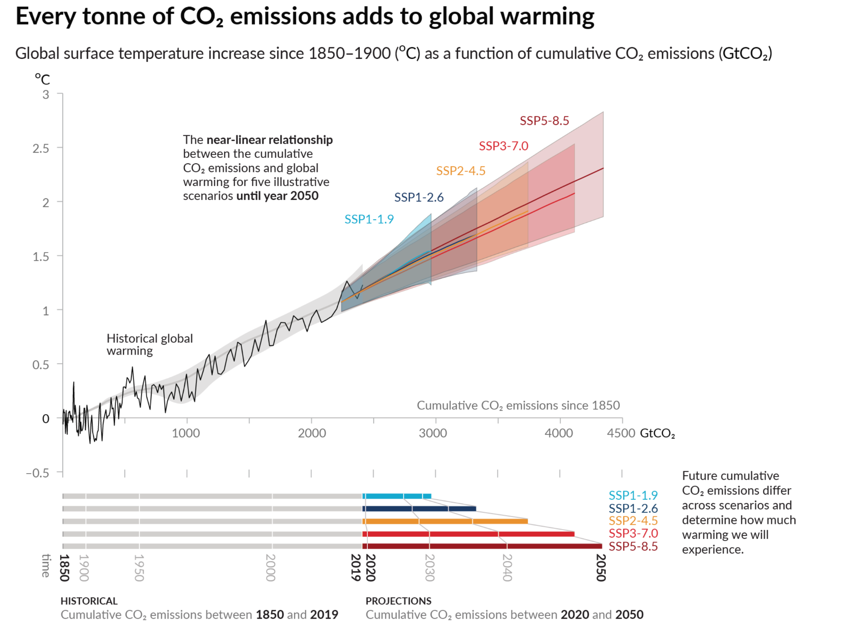

Carbon Budgets: Why Cumulative Emissions Dominate
A carbon budget is the total amount of CO₂ that can be emitted while keeping warming below a specified temperature threshold, such as those in the Paris Agreement. The IPCC’s central estimates of the remaining carbon budget from the beginning of 2020 for limiting warming to 1.5°C was 500 GtCO₂; for 2°C this was 1150 GtCO₂.
As set out in our article Carbon Budgets: From Concept to Implementation, the TCRE and global emissions to date imply the remaining carbon budget for 1.5°C has decreased to around 200 GtCO₂. At current emissions rates, this implies breaking the 1.5°C target within five years.
Carbon budgets follow directly from the TCRE. Because warming depends on cumulative emissions:
- Every year of positive emissions shrinks the remaining budget.
- The later emissions are reduced, the steeper future reductions must be.
- Early action has a disproportionately large impact on long-run outcomes.
This framing turns climate policy into an intertemporal allocation problem: society must decide how quickly to use up a limited remaining emissions budget.
Carbon budgets are therefore central to modern climate policy. They:
- Translate abstract temperature goals into quantitative constraints.
- Clarify why temporary emissions reductions are insufficient.
- Provide the logic behind net-zero targets.
Once net zero is reached, cumulative emissions stop rising, and temperatures stabilise. As long as emissions remain net positive, warming continues.

Standardised Scenario Frameworks: How Future Warming Is Described
To analyse future climate outcomes consistently, the IPCC uses standardised scenario frameworks. These do not predict what will happen, but instead describe what would happen under different assumptions.

Representative Concentration Pathways (RCPs)
RCPs are defined by the level of radiative forcing in 2100, measured in watts per square metre. Examples include: RCP2.6, RCP4.5, and RCP8.5
RCPs describe outcomes, not how the world gets there. They specify the physical forcing applied to the climate system, without detailing the socioeconomic conditions that generate it.

Shared Socioeconomic Pathways (SSPs)
SSPs extend this framework by combining emissions trajectories with narratives about how the global economy and society evolve (and can be seen on the figure above).
They incorporate assumptions about economic growth, technological change, institutions and governance, and inequality and development
Commonly cited examples include:
- SSP1-1.9: consistent with limiting warming to around 1.5°C.
- SSP1-2.6: around 2.0°C.
- SSP2-4.5: around 2.6–2.7°C, often described as “Middle of the Road”.
- SSP3-7.0 and SSP5-8.5: high-warming futures.
SSPs provide a common language for comparing studies and interpreting results across models and disciplines.
The key point is that SSPs are reference scenarios, not predictions. They are tools for structured analysis, not forecasts of where the world is heading.

Why Carbon Sense Uses SSP2-4.5
Carbon Sense uses SSP2-4.5 on its homepage because it most closely aligns with where the world appears to be heading under current policies and actions.
SSP2-4.5 is often described as a “Middle of the Road” pathway. It assumes:
- Incremental technological progress
- Uneven policy implementation
- Continued economic growth
- No dramatic global acceleration in climate ambition
It does not assume coordinated, transformative decarbonisation at the pace required for 1.5°C. Nor does it assume a breakdown of global cooperation or a return to unchecked fossil expansion. In other words, SSP2-4.5 reflects a world that is making progress but not fast enough.
Importantly, SSP2-4.5 is widely used as a baseline reference scenario in policy analysis. It allows comparisons across studies, models, and reports. Using it does not imply that the world is locked into that pathway. Rather, it provides a structured benchmark against which progress, or lack thereof, can be evaluated.

Where Current Policies Lead: Emissions Pathways
While SSPs provide structured reference futures, several independent groups attempt to estimate where current real-world policies are actually taking us.
One of the most widely cited is Climate Action Tracker. It aggregates national legislation, regulatory changes, and energy system developments to estimate implied temperature outcomes.
These assessments typically distinguish between three categories:
- Current policies imply approximately 2.6–2.7°C of warming by 2100.
- Pledges and targets imply approximately 2.1–2.3°C, if fully implemented.
- 1.5°C-compatible pathways require substantially stronger and faster reductions.
The gap between current policies and stated long-term ambitions is often referred to as the implementation gap. Governments have adopted targets since the Paris Agreement, including widespread net-zero commitments. However, near-term policy settings frequently remain inconsistent with those long-term goals.
This divergence between ambition and action is one of the defining features of contemporary climate policy — and a central focus of climate economics.

The Carbon Clock: What Carbon Sense Is Counting
The Carbon Sense homepage includes a live carbon clock. It is a simple device but has a serious purpose. It displays:
- Cumulative CO₂ emissions since 1 January 2026, and
- The implied rate of emissions per second.
It does so by assuming a constant annual global emissions rate and accumulating emissions through time.
For 2026, the clock assumes approximately 60.4 gigatonnes of CO₂ per year, based on a global emissions forecast from the World Emissions Clock.
At that rate, the world emits 1,914 tonnes of CO₂ per second.

Putting It All Together
Climate economics rests on a simple but powerful chain of logic:
- International agreements define goals.
- The IPCC sets the scientific guardrails:
  - Climate sensitivities link emissions to warming.
  - Carbon budgets translate temperature limits into quantitative constraints.
  - SSPs provide structured futures for analysis.
- Policy trackers show where current actions are likely to lead.
Taken together, these elements show that climate change is not merely an environmental issue. It is an intertemporal allocation problem under uncertainty, shaped by political feasibility, technological change, and distributional impacts across countries and generations.
Climate economics is therefore about choices under constraint: limited carbon budgets, uneven development, and the need to balance short-term costs with long-term risks.

Annex: Greenhouse Gases and CO₂-Equivalence (CO₂e)
Climate policy covers all greenhouse gases (GHGs), not only carbon dioxide. These include:
- Carbon dioxide (CO₂): long-lived and cumulative;
- Methane (CH₄): short-lived but highly potent;
- Nitrous oxide (N₂O): long-lived and powerful; and
- Fluorinated gases (F-gases): emitted in small quantities but extremely high warming potency.
Although CO₂ has a lower warming impact per tonne than several other greenhouse gases, it is responsible for roughly two-thirds of net anthropogenic warming to date because of the large increase in its atmospheric concentration since the industrial revolution.

Why Gases Differ in Climate Impact
The warming impact of a greenhouse gas depends on two key physical characteristics:
- Radiative efficiency: how effectively the gas absorbs energy and re-emits it as heat.
- Atmospheric lifetime: how long the gas remains in the atmosphere before being removed by natural processes.
For example:
- Carbon dioxide (CO₂) does not have a single atmospheric lifetime; while individual molecules cycle relatively quickly, a fraction of emitted CO₂ remains in the atmosphere for centuries to millennia.
- Methane (CH₄) has a high radiative efficiency but a relatively short atmospheric lifetime (about 12 years).
- Nitrous oxide (N₂O) persists for over a century.
Because these gases differ so substantially, policymakers convert them into a common unit: carbon dioxide equivalent (CO₂e).

Global Warming Potentials (GWP)
The conversion to CO₂e relies on Global Warming Potentials (GWPs).
GWP measures the total warming effect of one tonne of a gas relative to one tonne of CO₂ over a specified time horizon.
The most commonly used metric in climate policy is GWP100, the warming impact measured over 100 years.
Under IPCC AR6 estimates (GWP100):
- 1 tonne of CO₂ = 1 tCO₂e
- 1 tonne of methane (CH₄) ≈ 27–30 tCO₂e
- 1 tonne of nitrous oxide (N₂O) ≈ 273 tCO₂e
This framework allows emissions from different sectors — energy, agriculture, industry — to be aggregated and compared using a single metric.

Important Limitations
CO₂e is a powerful accounting tool, but it compresses very different climate dynamics into a single number.
- CO₂ is cumulative: warming depends largely on total historical emissions.
- Methane is short-lived: its warming impact is stronger in the near term but does not accumulate over centuries in the same way.
The choice of time horizon (e.g., 20-year vs 100-year GWP) can materially affect the relative weight assigned to methane. CO₂e is therefore extremely useful for policy design and emissions reporting, but it is not a perfect representation of physical climate processes.

The UNFCCC established annual Conferences of the Parties, or “COPS”. The most recent of which was held in Brazil in 2025.
UNFCC, Article 3, Principle 1.
UNFCC, Article 3, Principle 4.
UNFCC, Article 3, Principle 3.
For a list of these countries, see Kyoto Protocol, Annex B.
UNFCC, Article 3, Principle 3.
IPCC Sixth Assessment Report, Synthesis Report, Full Volume, paragraphs B.5.2 and 3.3.1.
IPCC Sixth Assessment Report, Synthesis Report, Full Volume, paragraph 3.3.1.
This Annex is based on Main Greenhouse Gases from the Center for Climate and Energy Solutions.
Figure SPM.10 in IPCC, 2021: Summary for Policymakers. In: Climate Change 2021: The Physical Science Basis. Contribution of Working Group I to the Sixth Assessment Report of the Intergovernmental Panel on Climate Change [Masson-Delmotte, V., P. Zhai, A. Pirani, S.L. Connors, C. Péan, S. Berger, N. Caud, Y. Chen, L. Goldfarb, M.I. Gomis, M. Huang, K. Leitzell, E. Lonnoy, J.B.R. Matthews, T.K. Maycock, T. Waterfield, O. Yelekçi, R. Yu, and B. Zhou (eds.)]. Cambridge University Press, Cambridge, UK and New York, NY,USA, pp. 3−32, doi: 10.1017/9781009157896.001 .]

